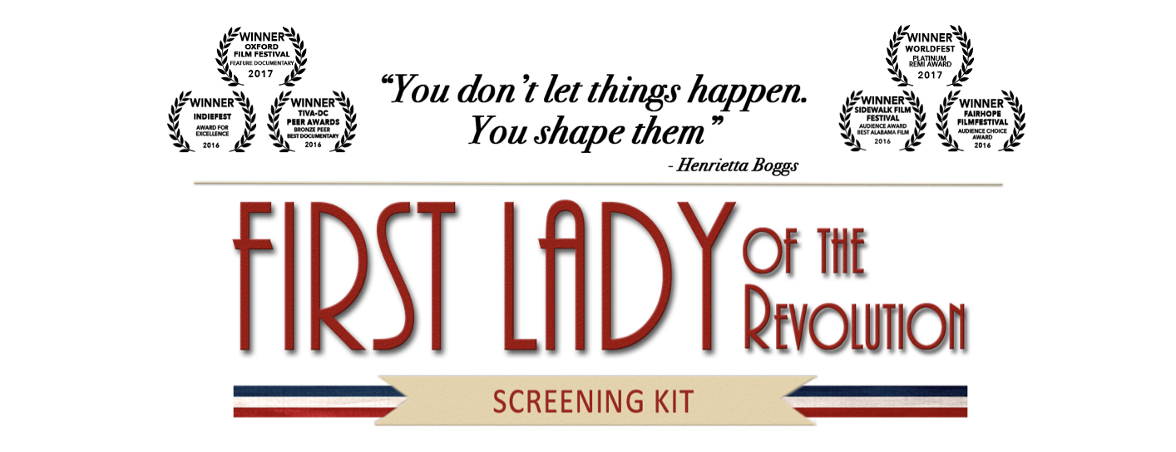
Invitation Email Template – Friends and Family

Once your Event Page is live, it’s time to get the word out! Start by sending emails to friends and family. They’re going to be your biggest supporters so it’s good to reach out to them first.

Email Subject:
Join me for a screening of First Lady of the Revolution on [Date]!

Email Body:
Dear family and friends OR Dear [Name},

I am hosting a special one-time screening of First Lady of the Revolution on [Date] at [Location]. I would love for you to join me for this event, and to help get the word out about this film. This award-winning documentary tells the remarkable story of Henrietta Boggs, who fell in love with a foreign land and the man destined to transform its identity. Her marriage to Jose ‘Don Pepe’ Figueres in 1941 led to a decade-long journey through activism, exile and political upheaval, and ultimately, lasting progressive reforms.

First Lady of the Revolution is not only a depiction of the momentous struggle to shape Costa Rica’s democratic identity; it’s also a portrayal of how a courageous woman escaped the confines of a traditional, sheltered existence to expand her horizons into a new world, and live a life she never imagined.

Check out the trailer for the film here: https://youtu.be/YJdanDExRJE.
The film was also featured on Alabama.com: http://www.al.com/entertainment/index.ssf/2016/08/first_lady.html.

It would be wonderful to see you in the audience, and I’d really appreciate you helping me spread the word. This is an opportunity to spend time with friends while watching an incredible true story.

Thanks for all your support, and I hope to see you there!

[Name]

