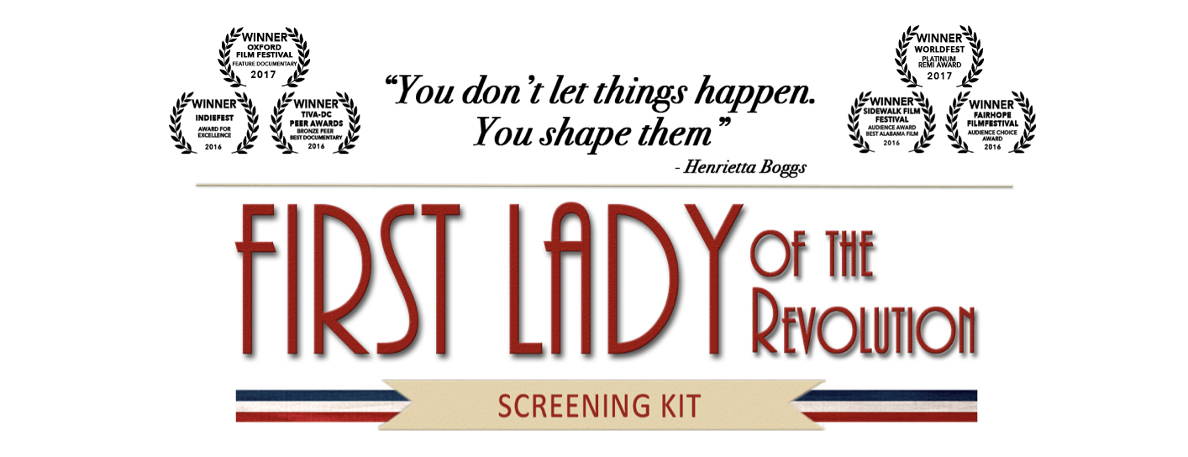
Invitation Email Template – Organization

You want an audience, and they want to see great films. Local arts organizations, non-profits, and film meet-ups are made-to-order partners to spread the word about your screening to a wider audience by telling their members!

Contact information for local organizations should be readily available and you can also reach out to them through their social media channels.

Email Subject:
We’re excited to collaborate with [Organization] on a First Lady of the Revolution Screening in [City]!

Email Body:
Dear [Name},

I am hosting a special one-time screening of First Lady of the Revolution on [Date] at [Location]. I would love for you to join me for this event, and to help get the word out about this film to your members while taking advantage of the opportunity to introduce your brand to a new audience.

First Lady of the Revolution is an award-winning documentary that tells the remarkable story of Henrietta Boggs, who fell in love with a foreign land and the man destined to transform its identity. Her marriage to Jose ‘Don Pepe’ Figueres in 1941 led to a decade-long journey through activism, exile and political upheaval, and ultimately, lasting progressive reforms.

First Lady of the Revolution is not only a depiction of the momentous struggle to shape Costa Rica’s democratic identity; it’s also a portrayal of how a courageous woman escaped the confines of a traditional, sheltered existence to expand her horizons into a new world, and live a life she never imagined.

What [Organization] Can do

Because this is an issue that matters to [Organization], we would love for you to help us get the word out via your membership and social media outreach.

In exchange for your support, we’re happy to have you or a member of your organization address the audience during the event, and we can also feature your organization on our Event Page. This is an ideal way to share your brand while also spreading the word about this incredible story. And you are uniquely positioned to help.

You can check out the trailer for the film here: https://youtu.be/YJdanDExRJE.
The film was also featured on Alabama.com: http://www.al.com/entertainment/index.ssf/2016/08/first_lady.html.

I would be delighted to have your input about other promotional ideas for this film, and of course, I’m happy to provide you any further information you may want. Can we arrange a time to talk, either in person or on the phone?

Thank you for your time and interest.

Best Wishes,
[Name]

